ANNUAL REPORT

2019-2020

Registered Company Number 10371450
Registered Charity Number: 1170810
CHAIRMAN’S INTRODUCTION

This financial year began with the last ever Open Stage Concert – always a happy occasion for the Odell members - and we thought that the rest of the year would be business as usual but it has ended with the sudden closure of the Centre due to the Covid-19 pandemic. In between these two events we have continued to improve our data gathering thanks to an Awards for All grant and we have begun the process of setting up a new project with a grant from the ESF.

Unfortunately I have to announce the death of one of our long serving trustees June Whiteman-Haywood. June was a loyal and good friend of the Trust for many years and served with dedication as a trustee until her illness last year. As you will see later in this report, our annual photography competition has been named in her honour and the trophy presented will carry her name. We have also said goodbye to two trustee; Gill Lane who was previously an employee of the Trust before she joined us on the Board and June Passey. Gill’s long experience of the day-to-day running of the Centre and June’s willingness to fundraise will be missed. We do, however, welcome two new trustees Sue Cowen and Jenny Perry, who will each bring her own knowledge and experience to the Board.

My fellow trustees have been working in the background over the year to ensure that we have the appropriate policies and procedures in place to provide a safe environment for staff and members. The Trust’s website has been updated to reflect the full range of activities and to make it easier to navigate and a small sub group has been looking at our Risk Register requirements. The staffing situation covered in the Manager’s report gave some of us the opportunity to become more involved in the daily life of the Centre and we learnt a lot and got pleasure from our increased contact with our members.

The financial situation is stable and we have ended the year with a surplus. I would like to record the Board’s grateful thanks to all those members of the public, carers and staff who generously gave money and their time to help us with ongoing support. I should also mention the shoppers who added their tokens to the fundraising bins to enable us to receive donations from both Tesco and Waitrose.

Finally, I would like to end as I started with the sudden closure of the Centre in March due to the lockdown imposed by the pandemic. I know that my fellow trustees would join me in saying that we will all be working together to get the Centre up and running again for all our members as soon as it is safe and legal to do so. We know how much the members will be missing their friends and the daily activities at the Centre but, in those immortal words ‘we will be back’.

Ann Masters
Chairman

MANAGER’S REPORT

The Odell Centre has, as usual, had another busy and eventful year. We continue to improve the activities on offer and to make the experience for our members as enjoyable and as safe as can be. There is a wide choice of Learning Disability and Mental Health day service provisions on offer within the Wyre Forest district and surrounding areas and it is vitally important that we keep our service relevant and fresh, not only to retain our current members, but to also attract new members to our service.

Work continues on improvements to our service as indicated by the inspection by Worcestershire County Council’s Quality Assurance and Compliance Team last year. We had another visit in June to review further progress on the agreed Action Plan and I am pleased to report that they were very complimentary about the improvements we had made so far and said we had ‘gone the extra mile’ to ensure that processes adopted are fit for purpose. Personal Development Plans for all members continue to be put together and reviewed on an annual basis.

We still have no definite decision from the County Council on the sale of the building and, as a consequence, a new lease was signed for another five years, with a suitable break clause.

Staff changes during the year include the appointment of Neil Marsh in July to replace our former employee Steve Madeley who sadly passed away following a serious illness. Liz Millinchip left us in June for pastures new and was replaced by Sue Kitson. Both Sue and Neil have been welcome additions to the team of Activity Coordinators. Anneliese Dudley broke her leg badly and was out of action for four months and I would like to take this opportunity to thank all the staff and also those trustees who helped cover activities during the summer months while she recovered and new staff were inducted. Gail Harding was also recruited in March to cover the role of Activity Coordinator on the Odell Centre’s brand new project called Work Train.

The Odell Centre’s kitchen staff team, led by Cook Linda Grainger, with Kitchen Assistants Lou Shannon and Mary Vessey, had an unannounced visit from Worcestershire Regulatory Services in October and yet again we received the top grading of 5 out of 5 for safety and hygiene. A fire safety inspection was also carried out on the building by WCC and they agreed to work being completed on fire doors and fire proofing the boiler room.

Staff training continued during the year with ongoing basics such as Food Safety, Health & Safety, First Aid, Safeguarding and Data Protection. I also continue to attend meetings with commissioners, the Local L.D. Provider Forum, as well as schools and colleges.

The Odell Centre is fortunate to have a staff team with a wide range of skills, all of whom have extensive experience in working with vulnerable adults and who are sympathetic to their needs and requirements. I would therefore like to thank everyone for their hard work and support over the year.

Craig Darby
Manager

ACTIVITIES:

The year started with a bang, with the last ever Open Stage Concert, which took place at Stourport Civic Centre. One of our trustees, Sue Nicholl, has been the driving force behind this wonderful annual event and this year’s was the most successful yet. We entered 4 acts, including a musical ensemble, 2 solo acts and a duet including piano accompaniment. Our members have loved the annual Open Stage Concert, as have many other learning disability groups and although this was the last one, it certainly didn't disappoint.

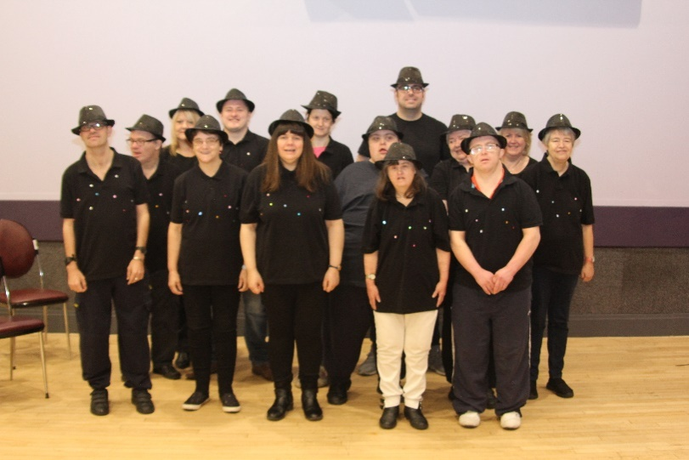

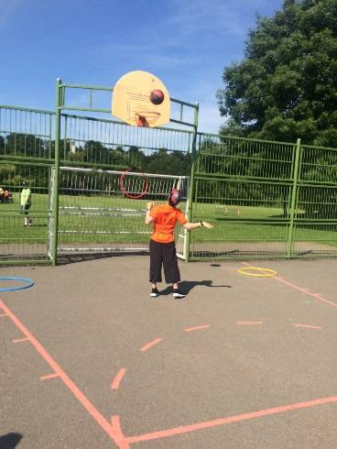
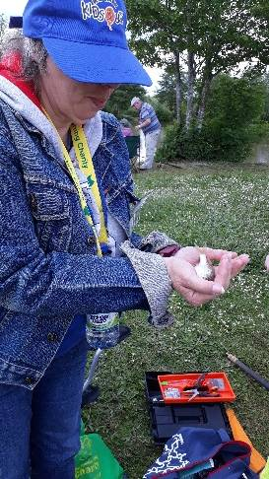
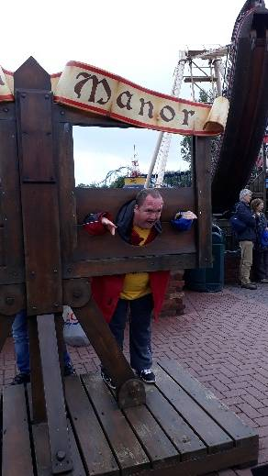
Other annual events taking place this year included day trips to Drayton Manor Park (courtesy of Stourport Rotarians), a visit to Weston-super- Mare, Sports Day at Bewdley Leisure Centre and the fishing competition (courtesy of Newfields Masonic Lodge in Halesowen). Our members love these special events which prove very popular every year.

Visits have also been made during the year to Open Door in Stourport for refreshments and entertainment including a performance of The Selfish Giant by Sea Legs Puppet Theatre. There was a trip around the Wyre Forest with Jeff Martin who gave a presentation on the history of the forest as well as deer spotting which the members enjoyed.

This year we decided to reinstate the annual Odell photography competition. This competition will now be named after June Whiteman-Haywood, who sadly died this year. June was a long standing trustee of The Odell Trust, a great friend of the Odell Centre and very supportive of everyone including members and staff. June’s husband funded the shield and other prizes and June’s daughter-in-law Sara Glover came along to present the shield to Tina Philpott, the first winner. The competition will now be an annual event.

There were two drama productions that members participated in during this period. There was our very own “Super Christmas” production based around Super Hero characters. Our new staff member Sue Kitson was producer and director and the members joined in with amazing interpretations of favourite characters. It was a wonderful way to kick off the Odell’s fun packed Christmas season.

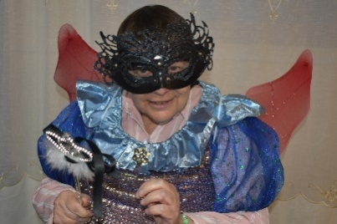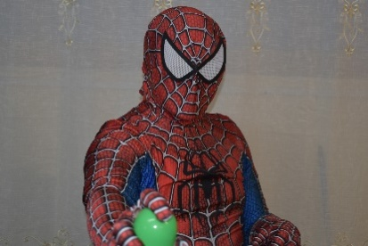

The second drama production involving Centre members was through the Workers Education Association (WEA) and took place at Trinity Methodist Church in Kidderminster. The production was called “Guardians of the Forest” and was a play based around saving the environment and set in the Amazon rainforest. This production was led by Judith Farrar and Sarah Tamar of Arte Etc and was supported by our own staff Sue Kitson and Mandy Watkins. Four performances took place in October – two during the day and two in the evening. Everyone involved had a great time.

Christmas

Christmas at the Odell Centre continues to be an annual highlight. The timetable is packed with seasonally based and extra special activities and events for our members to participate in and enjoy. In addition to the “Super Heroes” drama production other seasonal highlights included trips on the Severn Valley Railway and visits to Bodenham Arboretum, Safari Park and Webbs Garden Centre. A meal out at a local pub was arranged and also a visit to Malvern Festival Theatre to see the pantomime Aladdin.

We received visits from the “Animal Man”, Andy’s Magic and Elaine Ball’s “Wheely Different Theatre Company” for a Christmas sing song. The annual Christmas lunch was held at the Centre to include all members, trustees and important guests. For the first time we held the members’ Christmas Party and Disco at Kidderminster Carolians Rugby Club, which proved very popular.
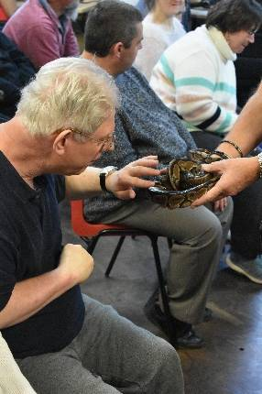
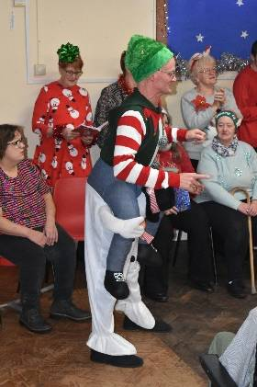
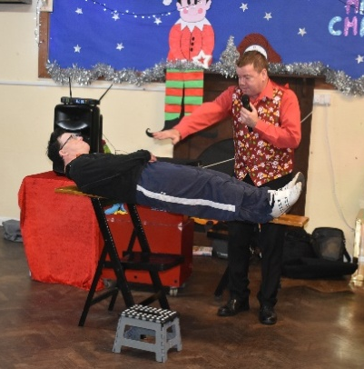

Awards for All Information Technology Grant

This grant enabled us to deliver an e-safety training course to our members and also allowed us to significantly upgrade both our IT hardware and software. This included issuing all Activity Coordinators with their own work tablet and installing a new Database onto all office computers and the tablets. This will allow staff to work more efficiently and, more importantly, record daily information following WCC Quality Team requirements.

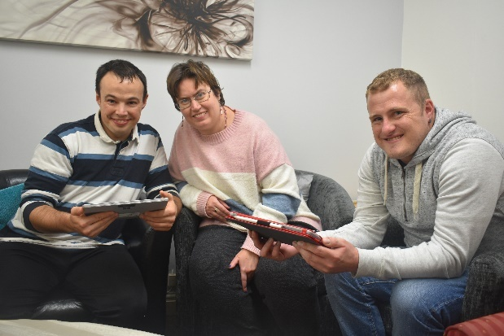

Work Train

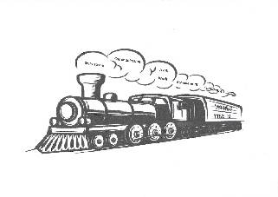
This is the name of our new project and is the result of receiving a grant from the European Social Fund (ESF), facilitated by WCC. Work Train will be operated at our Franche allotment site, although some aspects of the project will take place at the Odell Centre itself. Work Train will enable members who participate in the project to develop and improve skills such as communication, team working and confidence building and will start in April 2020

Members

During the year we received 8 new referrals and 4 members left. At the end of March 2020 there were 86 members on roll. One member who sadly died during the year was Robin O’Dell. Robin was very special to everyone connected to the Odell Trust as it was his father Eric’s vision and inspiration that resulted in setting up the Trust and the first day centre for people with a learning disability in the area. The other long serving member to pass away this year was David Mulready.

DONATIONS

Newfields Masonic Community Charity £50
Waitrose £230
Monday Night Group £400
Mrs Whittall £216.24
Open Stage £90.67
June Whiteman-Haywood estate £50,000
Awards For All (Lottery) £9,888
Robin O’Dell funeral collection £173
Steve Madeley funeral collection £570
Tesco £2,000
Home From Home Fitness £1,783.65
Clivestock £1,700
Kate Wellings Trust £2,985
Bernie Green £150
Christmas Raffle £672.31
Councillor Tracey Onslow £300
Mrs Guy £100
Sue Forester-Morgan £100
Mrs Buttery £20

Grateful thanks to all those who supported us during the year

FINANCE REPORT

INCOME |  |  | EXPENDITURE
 | Year to 31/3/2020 |  |  | Year to 31/3/2020
 | £ |  |  | £
WCC Personal Budget | 420,486 |  | Staff Costs | 294,841
Donations | 64,386 |  | Activities | 50,029
Grants | 2,497 |  | Support Costs | 74,305
Other Income | 5,935 |  | Governance/Investments exps. | 2,589
TOTAL | 493,304 |  | TOTAL | 421,764

ANNUAL SURPLUS £71,540

The trustees are pleased to report that the Trust has maintained a strong financial position. Despite an increase in expenditure from last year, the overall position has improved due to the Trust significantly increasing the level of income. This is partly due to a total of 19 generous donations received through the year, particular thanks are due to a very generous donation of £50,000.00 from the June Whiteman-Haywood estate. It should also be noted that from 21/8/2019 the daily rate for members paid by WCC increased. The quarterly payments by WCC went up by £62 to a total of £3812 per member.

The strong financial position has enabled trustees to review the Reserves policy. This has now increased from 6 to 9 months running costs, plus amounts for potential redundancies and other closure costs. With such a strong position, it is good to report that the Trustees are confident about the growth of the charity, and the consequent benefits this will bring to the members

A full set of accounts can be viewed on request.

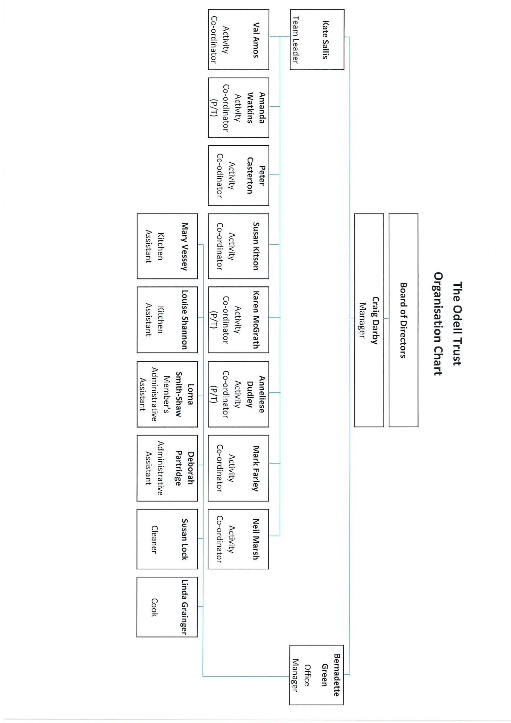

Governance Structure
The Trust became a Company Limited by Guarantee on 12th September 2016 and is governed by Articles of Association which established the objects and powers of the charitable company.

Charity Name
The Odell Trust

Charity Number
1170810
Company Number
10371450

Registered Address
The Odell Centre, Plimsoll Street, Kidderminster DY11 6TZ

Honorary President
Mr Ken Peers
Patron
Mrs Joyce Coley

Trustees
Mrs Ann Masters – Chairman
Mrs Sue Moreve – Vice Chairman
Mr Trevor Burgess
Mrs Sue Cowan - appointed 22.5.19
Mrs Jenny Perry -appointed 28.1.20
Mrs June Passey – resigned 18.11.19
Mr Alex Roberts
Mrs Sue Nicholl
Mrs Gill Lane - resigned 4.10.19
Independent Examiners
Cutter & Co Ltd
Lyttleton Court
3 Birmingham Street
Halesowen
Bankers
CAF Bank Ltd

NOTES ON GOVERNANCE STRUCTURE
Members
The subscribers to the Memorandum of Association and other persons elected by the Board of Directors shall, with their agreement, be admitted to membership of the Company.
Organisational Structure
The Board meets as often as required and, during this year, met 5 times. In between these meetings the Policy & Procedures Review group and Health & Safety Review group met on a regular basis. In addition various trustees had continued oversight of the Business Continuity Plan and Information Technology with everyone reporting back to the trustees at Board meetings.
The trustees have overall responsibility for ensuring the charity has systems of internal control in place and the PQASSO Quality System is in place. These measures are designed to give reasonable but not absolute assurance against material misstatement or loss. A budget is approved by the trustees annually and regular financial reports and forecasts are prepared for the Board.
Recruitment and Appointment of Directors
The directors of the company are also charity trustees for the purpose of charity law and under the requirements of the Memorandum and Articles of Association nine directors were originally elected to serve as Directors. Directors retire by rotation and elect a Chairman, Vice Chairman and Treasurer at each AGM. New directors would be identified and appointed by the remaining Board members.
Trustee Induction and Training
The Vice Chair of the trustees is responsible for the induction of any new trustee which involves awareness of the role and responsibilities of trustees, the governing documents, administrative procedures as well as the history and philosophical approach of the charity.
Related parties
There are no related parties this year

