ANNUAL REPORT

2020-2021

Registered Company Number 10371450
Registered Charity Number: 1170810
Chairman’s Report

This has been a difficult year for everyone but I think that the Odell Centre has managed to continue to provide a service, albeit not a normal service, to all our members. Most of the employees have been on furlough at some point in the year but the centre has been kept going by office staff working from home or an empty centre. Grateful thanks to all our employees for the way they have devised new activities whilst working in difficult circumstances when we were able to re-open.

It is with sadness that I have to report the death of two of our founder members during the year. Ken Peers, who was our Chairman for many years who became our Honorary President when he stood down and Joyce Coley, who was Vice Chairman, Chairman and then Patron of the Trust. They were the driving force behind the setting up of the original trust and securing the use of our current premises and everyone is very grateful for the work they did on behalf of the members.

We have been joined on the Board by two new trustees; Keith Slater and Alan Wardle. They have both managed over time, to acquaint themselves with what is happening within the trust despite not having been in the centre after appointment, or having the chance to meet their fellow trustees because of all the restrictions.

During the year all the meetings of the trustees have been held on Zoom. Many of these were updates on precautions being taken and confirmation of measures being put in place for our eventual re-opening in September. Thanks to my colleague Sue Nicholl for fac ilitating these meetings.

Some of our members chose not to return when the centre reopened, but most came back to enjoy the limited activities we were able to provide. Our financial position remains steady and, as far as our future plans are concerned, we are still in negotiations to rent additional space and possibly buy the whole building so that we can increase the numbers of people we can welcome into our centre.

Finally, grateful thanks to everyone who has continued to support us throughout the year. Grants and donations are recognised elsewhere in the report, but I would like to make particular reference to Worcestershire County Council, who have helped us cover the costs associated with re-opening the centre.

Ann Masters

Manager’s Report

At the start of this reporting period (April 2020), the UK was just a week and a half into the first lockdown of Covid-19. The Odell Centre has been greatly affected by the impact of Covid-19, not least by the fact that our centre was closed for some 5 ½ months. Our day service literally came to a standstill overnight and sadly, there have been very few positives to take from Covid-19 descending upon us.

The greatest impact from Covid-19 has been on our members who attend the Odell Centre. The Odell Centre belongs to them. It is a place to come along and meet their friends and to participate in stimulating activities. So, for the centre to close for an extended period, due to the impact of Covid-19, has been dreadful for our members. It has had a major impact on the mental well-being of many of them, to an extent that some never returned upon our reopening at the beginning of September.

When we first closed at short notice, most staff were furloughed, with office staff working from home and myself as the solitary staff member on site. All members received a weekly phone call from staff and a plan was put into place with regards to posting out weekly activity packs, commensurate with the size of the individual member’s day service package. As the weeks and months passed by, Zoom calls were introduced to keep in touch with members and as the initial Covid-19 rules were slightly relaxed, activity pack deliveries were made in person by staff, to give a more personal approach to maintaining contact with members.

Retirements during this period included Mary Vessey and Lorna Smith-Shaw in December 2020, both of whom served the Odell for over 25 years. Mary was employed in various roles during her time working for the Trust - Deputy Manager, Activity Coordinator and Kitchen Assistant. Lorna worked in the office as the members’ admin assistant. Anneliese Dudley also retired as an activity coordinator in September 2020, but will continue to work for the Odell as bank staff as and when required. Many of the staff completed online training during the year to maintain their skills and competences.

The few positives to come out of Covid-19 relate to the excellent work of the staff during this period to help to keep the centre as safe and as clean an environment as possible and to adhere strictly to Government advice. So far, we have spent in the region of £40,000 on safety measures, introduced as a direct result of Covid-19. This heavy financial outlay has been fully justified however, because once we reopened on 7th September, we have not been greatly impacted by Covid-19 outbreaks here, even though our day service takes place predominantly in an enclosed traditional day centre environment.

Craig Darby

Covid-19 Safety & Hygiene Precautions

During the 5 ½ month period that we were closed leading up to September 7th, we implemented numerous measures with no expense spared, to make the Odell Centre as safe as possible in the circumstances. These measures have included ripping up all carpets in the building and replacing with anti-slip vinyl flooring, replacing all windows to improve air circulation and having bespoke Perspex partition screens made to aid social distancing. We have also invested in a floor scrubbing machine, fogging unit and an automatic temperature reading machine. Large quantities of PPE and hand sanitizer were bought and an enhanced cleaning schedule was introduced.

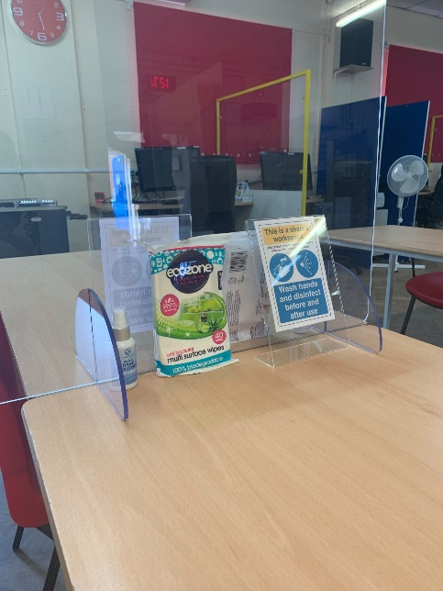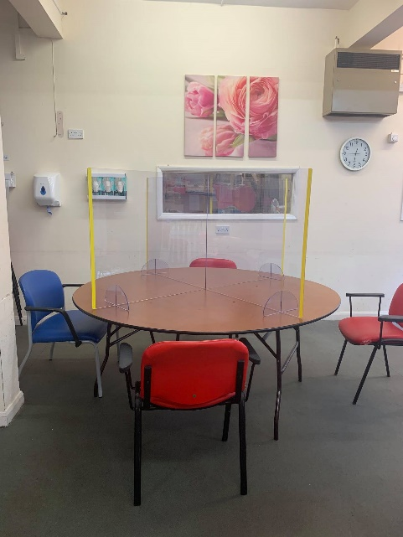
Perspex screens on tables

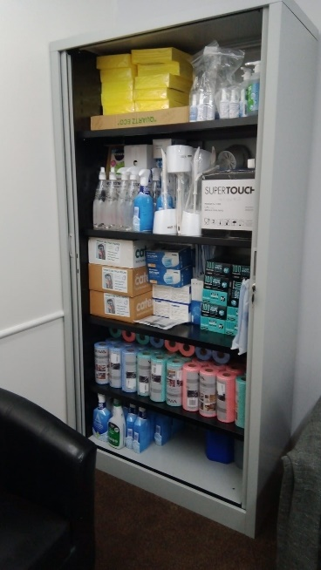
Cupboard full of PPE supplies

In order for us to reopen our day service to our members, other behind the scenes measures had to be completed, which included a review of our Covid-19 health and safety measures and the introduction of Covid-19 related risk assessments regarding our premises and vehicles, individual members and individual activities. Those staff still on furlough returned to work at the beginning of September, ahead of our members returning to the centre a week later.

To help our members understanding of social distancing, we bought coloured circular rubber mats and spaced them out on the floor throughout the centre as a visual aid.
Activities

Once the initial shock of the speed of closure of the centre was over, staff not on furlough began to organise activities for members that they could undertake at home. All members received a weekly phone call from staff and a plan was put into place with regards to posting out weekly activity packs, commensurate with the size of individual member’s day service package. Weekly activity packs were posted out or delivered by hand to our members, mainly arts and craft based activities but also quizzes. In addition, we sent out gardening type activities, including growing plants from seed and also cooking activity packs. We introduced Zoom sessions, so that members at home could join in, including bingo, quizzes, cooking sessions and dance for wellbeing.

As the weeks and months passed by, Zoom calls were introduced to keep in touch with members and as the initial Covid-19 rules were slightly relaxed, activity pack deliveries were made in person by staff to give a more personal approach to maintaining contact with members.

Working from home

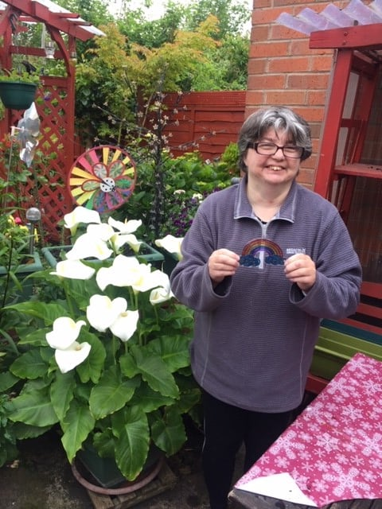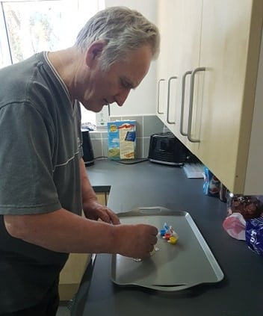

As Lockdown 1 progressed, some staff were taken off furlough to carry out much needed functions, such as work at the Odell’s allotments, including the introduction of raised beds and flat slabbing areas at our Franche allotment site.

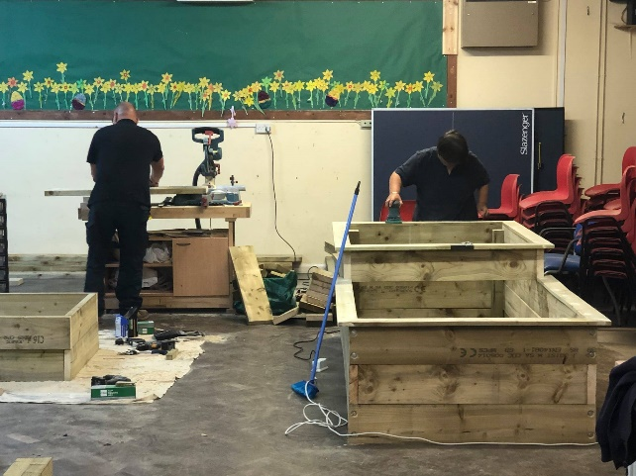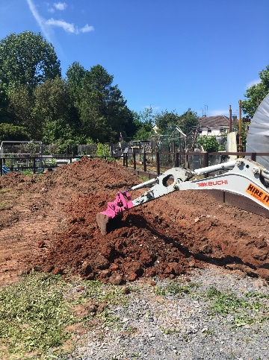

In order for us to reopen our day service to our members, other behind the scenes measures had to be completed. Those staff still on furlough, returned to work at the beginning of September to prepare the centre, ahead of our members returning a week later.

When the Odell Centre reopened on September 7th, there were a number of activities, which, due to Government legal restrictions in place, we simply have not been able to reintroduce. These include all sport and fitness type activities and also music / singing activities and beauty / pampering sessions. For an extended period, we have had to open with a very limited and restrictive timetable of activities for our members.

However, the staff have been very creative at organising activities that could be undertaken, despite of the restrictions in place. These were mainly art or craft based.

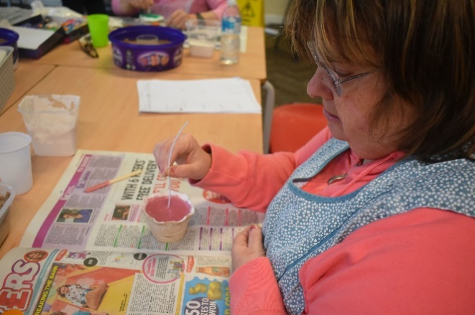

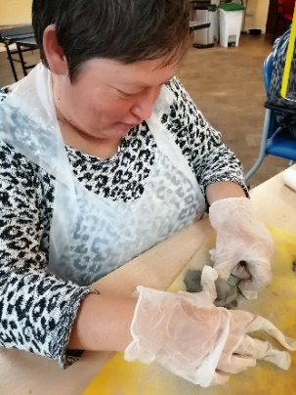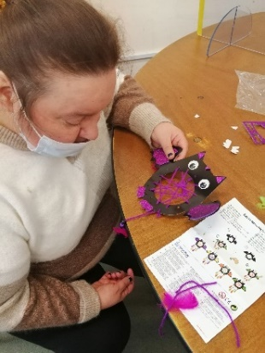
We were able to run more activities at our Franche allotment site as part of the Work Train programme. During this period, early potatoes, onions and shallots were planted, along with Swiss chard. Raised beds were painted, as was the fencing we erected around the perimeter of our allotment plot.

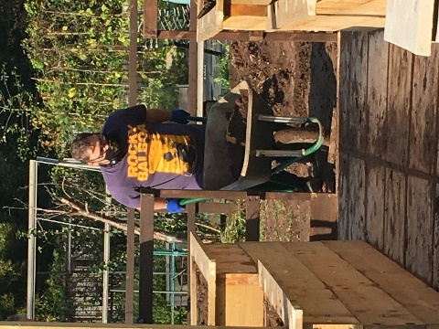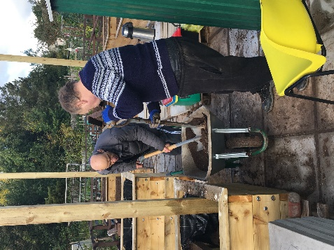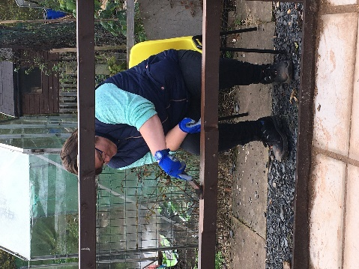

Christmas

Unfortunately, due to the impact of Covid-19, the Christmas period, which in normal times is a magical and joyous time at the Odell Centre, was alas, very limited this year, due to the severe Government restrictions in place. Arts and crafts had a Christmas theme and the centre was able to erect and decorate the usual Christmas tree and Father Christmas put in an appearance, although not in human form this year (see photographs)

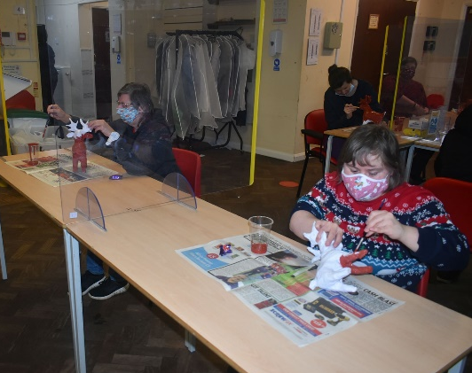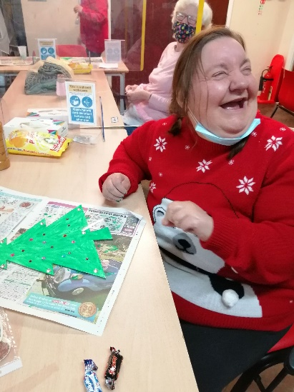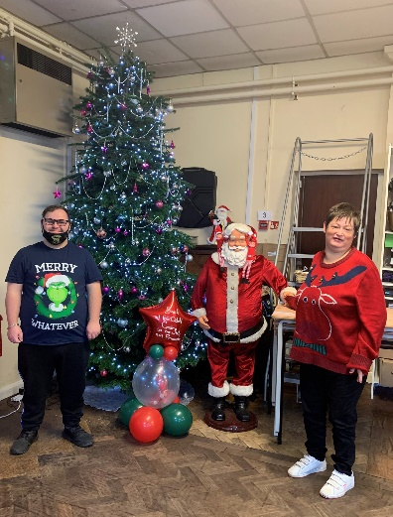

We arranged a couple of visits to Bodenham Arboretum to follow the nativity trail to see the animals.

Other

During this period we invested heavily in an electronic signing-in system called InVentry for anyone entering or exiting the building. InVentry has replaced our antiquated signing in / signing out book and has transformed how we now record information. It not only helps with signing in / out, but also helps office staff collate relevant reports and is also used for fire procedures.

Donations

Grateful thanks to all those who supported the Odell Trust through this difficult year.

PayPal (anonymous) |  | 202.31
Monday Night Club |  | 450.00
Sera Bove |  | 20.00
David Morris - collection |  | 500.00
Tesco Groundworks |  | 500.00
Big Local DY10 |  | 2,000.00
Waitrose |  | 333.00
Geraldine and Michelle Edwards |  | 100.00
PayPal - Mr and Mrs Whittall |  | 243.65
Co-op |  | 250.00
Philip Harris' family |  | 100.00
Wyre Forest Lottery |  | 83.00
Mr & Mrs Buttery |  | 25.00
Mr George Johnson |  | 50.00
Amazon Smile |  | 25.00
PayPal (anonymous) |  | 45.13
Mrs Greening - J Coley's Neighbour |  | 20.00
Tesco Groundworks |  | 1,000.00

Grants

Active Herefordshire & Worcestershire Grant for Zumba, Music/Dance/Tai Chi, Boxercise and Golf Session |  |  | 5,000.00
WCC Infection Control Fund |  |  | 68,625.00
National Lottery Awards For All – Sports/Exercise Sessions  HMRC – Job Retention Scheme |  |  | 9,985.00  60191.00

Finance Report

INCOME |  |  | EXPENDITURE
 | Year to 31/3/2021 |  |  | Year to 31/3/2021
 | £ |  |  | £
WCC Personal Budget | 392,451 |  | Staff Costs | 344,945
Donations | 6,067 |  | Activities | 47,476
Grants | 150,909 |  | Support Costs | 96,578
Other Income | 32.110 |  | Governance/Investments | 3,685
TOTAL | 581,537 |  | TOTAL | 495,379

ANNUAL SURPLUS £86,158

Once again, the trustees are pleased to report that the Trust has maintained a strong financial position over the year ending 31st March 2021. Despite the fact that the trust has significantly increased expenditure from last year, the overall financial position has improved, thanks to a significant increase in the level of income. There has been a large drop in donations, but this shortfall has been more than addressed by a very large allocation of grants to the trust. These have often been to cover required Covid-19 expenditures.

The strong financial position has enabled trustees to increase further the funds put aside into the Reserves. In addition to the 9 months’ worth of running costs, a further amount of £50,000 has been set aside for building maintenance and vehicle replacement.

With such a strong financial position for the Trust, the Trustees are confident about the growth of the charity, and in turn, the consequent benefits this will bring to the members.

A full set of accounts can be viewed on request.

Alan Wardle
Treasurer

Governance Structure
The Trust became a Company Limited by Guarantee on 12th September 2016 and is governed by Articles of Association which established the objects and powers of the charitable company.

Charity Name
The Odell Trust

Charity Number
1170810
Company Number
10371450

Registered Address
The Odell Centre, Plimsoll Street, Kidderminster DY11 6TZ

Trustees
Mrs Ann Masters – Chairman
Mrs Sue Moreve – Vice Chairman
Mr Trevor Burgess
Mrs Sue Cowen
Mrs Jenny Perry
Mr Alex Roberts
Mrs Sue Nicholl
Mr Keith Slater – 30.04.20
Mr Alan Wardle – 25.06.20

Independent Examiners
Cutter & Co Ltd
Lyttleton Court
3 Birmingham Street
Halesowen
Bankers
CAF Bank Ltd

NOTES ON GOVERNANCE STRUCTURE

The object for which this charity is established is to provide a Recreational Day Centre to support individuals who live in Worcestershire or the surrounding area for recreation or other leisure time occupation. This provision sets out to improve the conditions of life for those who have need of such facilities through disability, age, youth, infirmity, financial hardship or social circumstances.
Members
The subscribers to the Memorandum of Association and other persons elected by the Board of Directors shall, with their agreement, be admitted to membership of the Company.
Organisational Structure
The Board meets as often as required and, during this financial year, met more frequently and remotely over Zoom. In between these meetings, the Policy & Procedures Review group continued to meet via Zoom, but other groups such as Health & Safety, could not meet due to government restrictions.
The trustees have overall responsibility for ensuring the charity has systems of internal control in place and the PQASSO Quality System is in place. These measures are designed to give reasonable but not absolute assurance against material misstatement or loss. A budget is approved by the trustees annually and regular financial reports and forecasts are prepared for the Board. A Risk Register is being produced to ensure that the trustees understand the risks faced by the charity and plan for the management of those risks.
Recruitment and Appointment of Directors
The directors of the company are also charity trustees for the purpose of charity law and under the requirements of the Memorandum and Articles of Association. Directors retire by rotation and elect a Chairman, Vice Chairman and Treasurer at each AGM. New directors are identified and appointed by the remaining Board members.
Trustee Induction and Training
The Vice Chairman of the trustees is responsible for the induction of any new trustee, which involves awareness of the role and responsibilities of trustees, the governing documents, administrative procedures, as well as the history and philosophical approach of the charity. Additionally, Safeguarding Vulnerable Adults training for members of the Board was conducted over the internet in June.
Related parties
There are no related parties this year.

